b  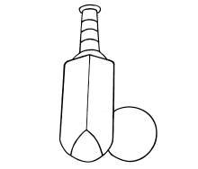 | c  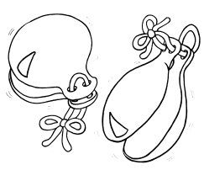 |  | ch  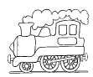 | d  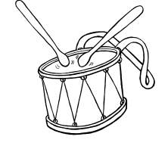 | f  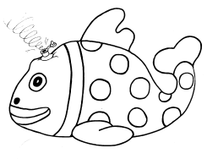 | g  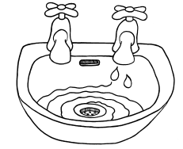 | h  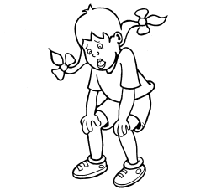 | j  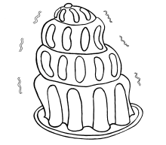 | l  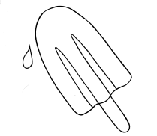 | m  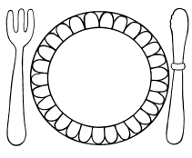 | n  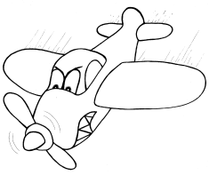 | ng  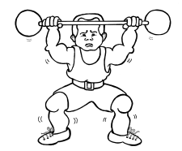
b  bb | c  k  ck  ch  q (qu)  que |  | ch  tch  t (ure) | d  dd | f  ff  ph | g  gg  gue | h  wh | j  g  ge  dge | l  ll  le  el  al | m  mm  mb | n  nn  kn  gn  pn  mn | ng  n (k)
p  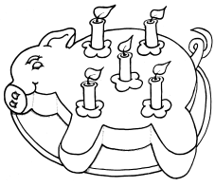 |  | r  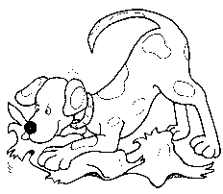 | s  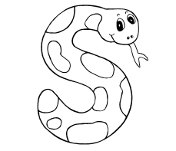 | sh  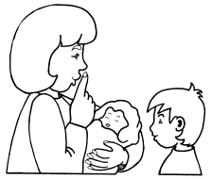 | t  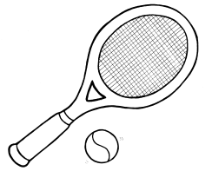 | th  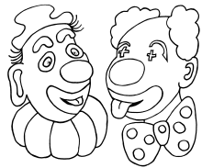 | v  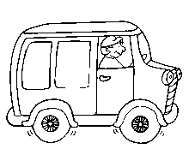 | w  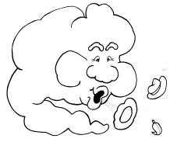 | x  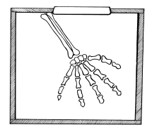 | y  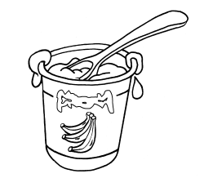 | z  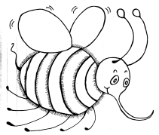
p |  | r  rr  wr | s  ss  st  se  c  ce | sh  ch  ti  ci  ss(ion,  ure)  s (ion,  ure) | t  tt | th | v  ve | w  wh  u (qu) | x  sounds  like  k/s | y | z  zz  ze  s  se  x

a  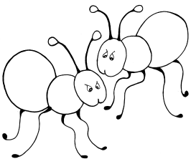 | air  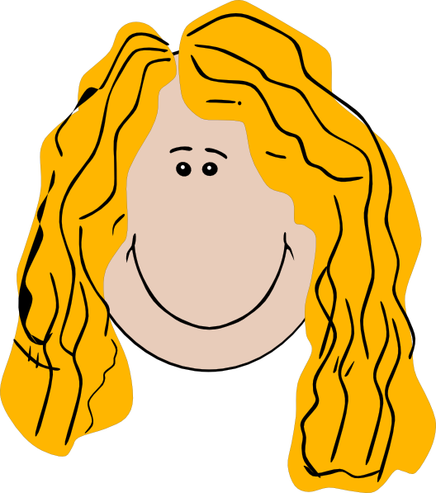 | ar  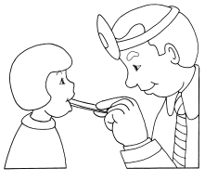 | ai  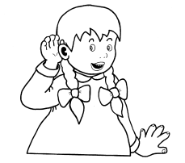 | e  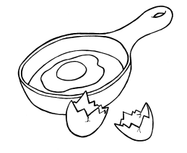 | ear  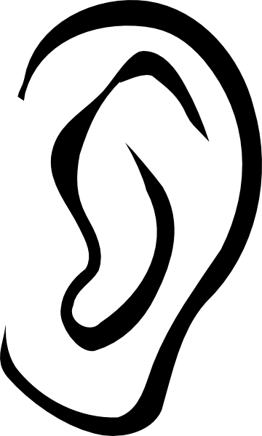 | ee  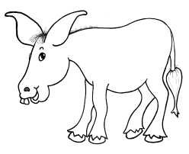 | er  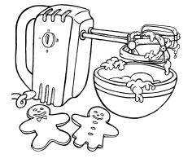 | i  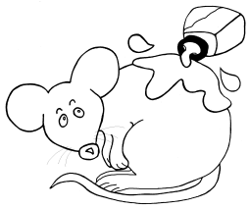 | ie  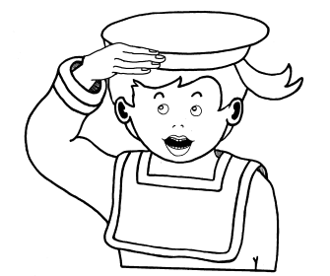
a | air  are  ear  eir  ere | ar  a  al  ear  are | ai  ay  a_e  a  ei  eigh  ey  ea | e  ea | ear  eer  ere  ier | ee  ea  e_e  ie  y  ey  e  ei  eo | er  ir  ur  or  ear | i  y  e | igh  i_e  ie  i  y
o  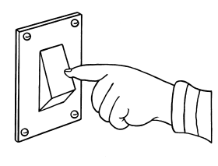 | oa  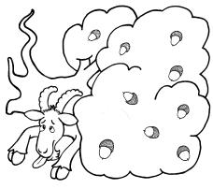 | oo  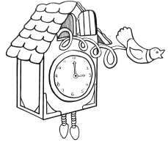 | oo | oi  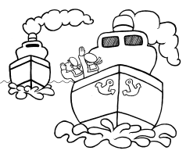 | or |  | ow  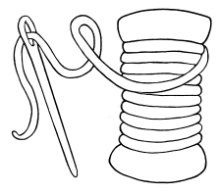 | u  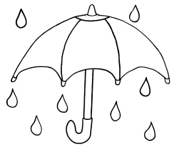 | ure  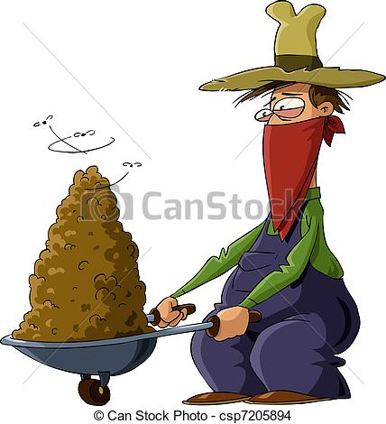
o  a | oa  ow  oe  o_e  o  ough | oo  u  oul | oo  ue  u_e  ew  ui  ou  ough  u | oi  oy | or  oor  ore  aw  au  augh | our  a  al  ar  oar  ough | ow  ou  ough | u  o | ure

