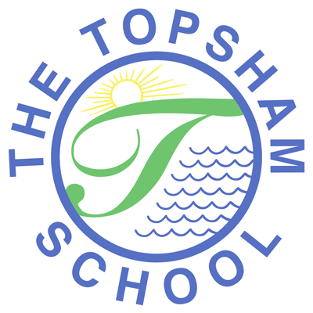
The Topsham School
A love of learning and commitment to the success of
every child at the heart of all we do

Headteacher: Mrs Emma Pipe
Orchard Way
Topsham
Exeter
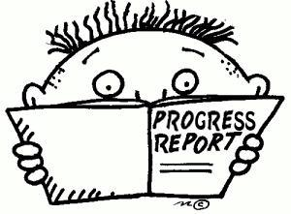
EX3 ODN
admin@topsham.devon.sch.uk
01392 874498

11th February 2021

Dear Parents/ Carers

Mid-Year Reports are being finalised and will be sent out, electronically, on Friday 19th March. Due to the National Lockdown our reports will be slightly different from previous Mid-Year Reports and we hope will be helpful to parents.

The report contains information on your child’s Attainment, Progress and Attitude to Learning based on the last summative data teachers have; this is data from the end of the Autumn Term 2020. This information is presented in the form of a grid and is colour coded like so:

*Key for  Attitude to Learning | Outstanding |  | Consistently good |  | Inconsistent |  | Cause for concern
*Key for  Progress: | Making exceptional progress |  | Making expected progress |  | Limited progress |  | Cause for concern
*Key for  Attainment: | 4 | Working at greater depth | 3 | Working at the expected standard | 2 | Working towards the expected standard | 1 | Working below year group objectives

Teachers will also be providing an overview of your child as a learner; when working in school and remotely and will include information on your child’s developing Learning Powers and their ability to work both collaboratively and independently.

In terms of expectations in relation to children’s attainment, we would expect the vast majority to be working at the expected standard to ensure they achieve Age Related Expectations by the end of the year. Some children will be working beyond Age Related Expectations and be working at Greater Depth. For those children not working at the expected standard yet, teachers will already have identified this and interventions and support will be in place to try and ensure the child is on track by the end of the year.

In terms of progress, the school strives to ensure ALL children make expected progress by the end of the year. Again, if a child is not making expected progress, teachers will be aware of this and relevant support will be in place to accelerate their progress.

However, our children have now experienced two National Lockdowns, which have had a significant impact on their progress and attainment. This is the same for ALL children across the country. We know that due to this, the picture of our children’s attainment and progress may be very different from what we would have expected in previous years. Please can I reassure parents that the teaching staff will continue to do all they can to ensure that ALL of our children make the most progress they can during these very challenging times.

Thank you for your ongoing support.

Kind Regards

Emma Pipe
Headteacher

