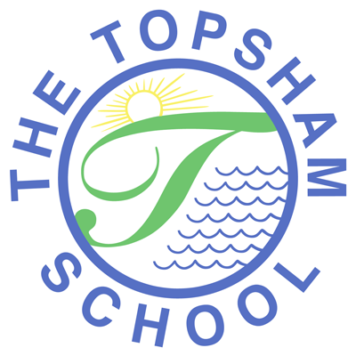
The Topsham School
A love of learning and commitment to the success of
every child at the heart of all we do

Headteacher: Mrs Emma Pipe
Orchard Way
Topsham
Exeter
EX3 0DN
admin@topsham.devon.sch.uk
01392 874498

5th June 2020

Dear Parents and Carers,

I am writing to inform you of a change to the Remote Learning in the coming weeks. I want to thank you for all of the hard work you are putting in to your learning at this time. We know how hard you are all working.
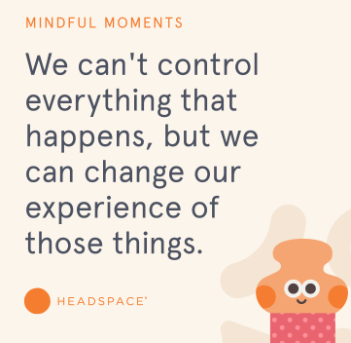
As we begin to welcome back some of the classes, you will appreciate that school for these children, and for the staff, will not be a ‘normal’ school experience. The children who are returning are in much smaller groups and cannot socialise, at any point with another group. This means that learning time, break times and lunch times are separate and staggered. The school is currently being and will continue being transformed to accommodate the children returning, to keep in line with social distancing and the removal and set up of resources. All staff that can be in school at this time, are in.

Due to this, and the latest Government guidelines on Remote Learning, we have to make some adjustments. We are very aware of the needs of the children who will not yet be returning to school and want to be able to continue to provide learning for them. However, we cannot continue to provide in the way that we have been so far.

Remote Learning from Monday 8th June will be as follows:
Instructions will continue to be given on Google Classroom each week. The children still need to access their learning from this platform.

Maths and Literacy: Teachers for KS1 and KS2 will set a sequence of lessons from government suggested websites, such as BBC Bitesize and Oak Academy. This is a different way of working for us and for you. We will also continue to use MyMaths and TTRS/ Numbots. Teachers for the Early Years may use these sites and other resources.
These are full lessons and activities for the children to follow and take part in. Teachers will carefully select the learning for children to follow and will take into consideration the time frames of each ‘lesson’. Therefore, teachers may set one lesson over two days.
Reading: Children will be expected to read each day. They can use their own books or any of the websites that provide digital books, such as Oxford Owl and MyON.
Early Years and KS1 = 15 minutes each day
KS2 = 30 minutes each day.

KS1 and KS2 Spelling: The Statutory Spelling lists for each year group will be uploaded to Google Classroom, along with spelling strategies. Each week, the children will be expected to practise and learn these words.

Early Years Phonics will continue to be set.

Topic: The Topic Pick and Mix Grids will continue. As the term moves forward, the topic based learning and activities will move towards a PSHE theme, to include relationships, self, managing change and emotion and transition.

Feel Good Friday will continue

Submission:
The children will still be asked to ‘submit’ when they have completed the maths and literacy lessons, so that teachers can keep track. This instruction will be clear on Google Classroom each week.

If there are any concerns or problems, the children can still write these in the comments box to their teacher. Please note that from next week, the timings that teachers will be able to be online will be different from previously. It is likely to be a given hour in the afternoon where teachers can be released from teaching and supporting classes. The children will be asked to comment on the reading they have completed each week. This will be clear on Google Classroom each week.

Topic instructions will be given on the grid.
Spelling DOES NOT need to be submitted.
Reading DOES NOT need to be submitted.

Additional:
- Your child’s teacher will continue to do all that they can to provide for and support your child. Remote learning is not ideal, and this is another way we are having to learn to adapt. But this is what we have at the moment, so please bear with us.
- If you have any queries about your child’s learning, please still email them directly. Try to avoid communications on Google Classroom with teachers as a response will be quicker and easier through email.
- Please keep to the timings that we have suggested for each subject. For example, if the maths is taking 2 hours and your child is finding it tricky, this is too long and you should stop, telling the teacher so that they know.
- I know many children may be losing motivation as they have been out of school for so long. It may help to revamp or revisit the day’s learning timetable or change the routine or the free play activities.
Kind regards

Miss White
Deputy Headteacher

