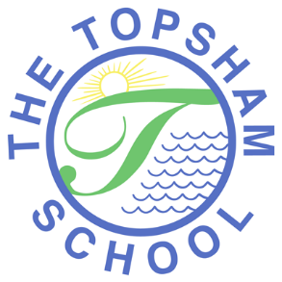
The Topsham School
A love of learning and commitment to the success of
every child at the heart of all we do

Headteacher: Mrs Emma Pipe
Orchard Way
Topsham
Exeter
EX3 0DN
admin@topsham.devon.sch.uk
01392 874498

22nd October 2020

Remote learning policy
Dear parents and carers,

As part of our continued commitment to your child’s education, both at school and home, we have developed a ‘Remote Learning Policy’. This aims to meet the needs of all our learners, whilst planning for all Covid related isolation and lockdown scenarios. This has been developed in consultation with staff, relevant governors and ‘parent voice’ through the parent survey, which took place at the end of the Summer Term 2020.

Schools are now required to provide a robust level of education for all pupils at home when they are having to receive remote learning, either as a result of a period of isolation or lockdown due to the Covid-19 pandemic.

Our Remote Learning Policy outlines how we plan to deliver this learning. It also aims to provide clear expectations of teachers, parents and children, to ensure all our children are able to access and effectively engage in, high quality remote teaching and learning opportunities should a period of home learning be needed.

Please take the time to read through the policy as well as the home/school agreement that we require you to sign. The policy can be viewed on our website via the following link: http://www.topsham.devon.sch.uk/policies.html

We would ask that you electronically sign and return the attached agreement by email no later than Friday 6th November 2020, so that we have all permissions in place, should any of the scenarios need to be implemented. The agreement is a Word document, so once you have read through, you are will be able to type your name in the box and send by email to jadesina@topsham.devon.sch.uk.

Within the policy and agreement are details of what forms of teaching will be utilized, including the use of ‘live’ teaching, as and when appropriate, and the amount of time we expect children to be spending on each aspect of their learning each day. We have tried to achieve a balance between independent work and class teacher direction through live teaching and the use of videos; please note ‘live’ teaching takes many forms including the use of on-line providers who are supporting schools in delivering ‘live’ teaching such as ‘Oak Academy’.

It is important that we all understand that schools can only provide remote learning with the resources they currently have. Schools locally have received no further government funding, training or resources in relation to remote education and so we are all at different points in terms of the technology we have to provide remote learning. Please know that as we continue to further develop our skills in this area, we will make any amendments and changes that we deem necessary to further improve this area of our provision.

As always thank you for your continued support at these times.

Kind regards

Emma Pipe
Headteacher

