The Topsham School
A love of learning and commitment to the success of
every child at the heart of all we do

Headteacher: Mrs Emma Pipe
Orchard Way
Topsham
Exeter
EX3 0DN
admin@topsham.devon.sch.uk
01392 874498

25th November 2020

Dear Parents/Carers

Please read the following information to relation to parent consultation evenings.

When will they take place?
Tuesday 8th December and Thursday 10th December from 3.45pm.

Which Year Groups will be included?
Every year group will be included apart from Little Acorns. Parents of our Little Acorns will have their parent consultations at a different time in the Spring Term and more information on these meetings will be shared after Christmas.

Mr Vernon and Mrs Owens will be present at all remote Big Acorns Parent meetings. Please can Big Acorn parents click on Mr Vernon to book appointments. Thank you.

How will they be facilitated?
Due to CV restrictions, parent consultations will be held remotely using School Cloud.

What is School Cloud?
It is an online booking system created just for the purpose of parent/teacher meetings. It can be accessed from any device, including a mobile phone.

How does it work?
Parents need to put this link into their browser https://topshamschool.schoolcloud.co.uk/ and this will take you straight to the appropriate page.
Follow these steps to help:

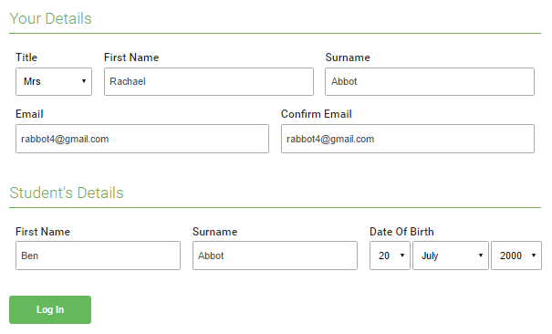 | Step 1: Login  Fill out the details on the page then click the Log In button.  A confirmation of your appointments will be sent to the email address you provide.

You must use the email address that you have registered to use Schoolcomms. This is the address School Cloud will recognize.

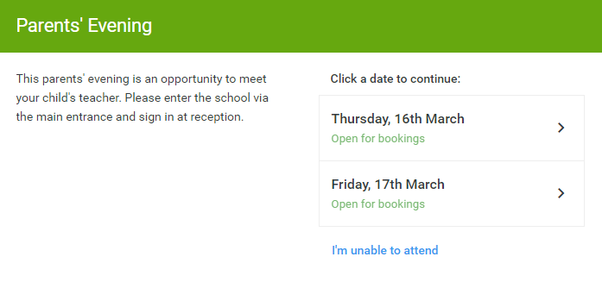 | Step 2: Select Parents' Evening  Click on the date you wish to book.

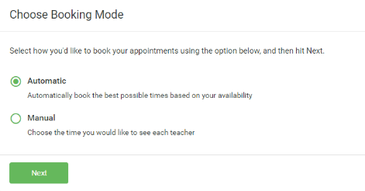 | Step 3: Select Booking Mode  To pick the times to book with each teacher, choose Manual. Then press Next.
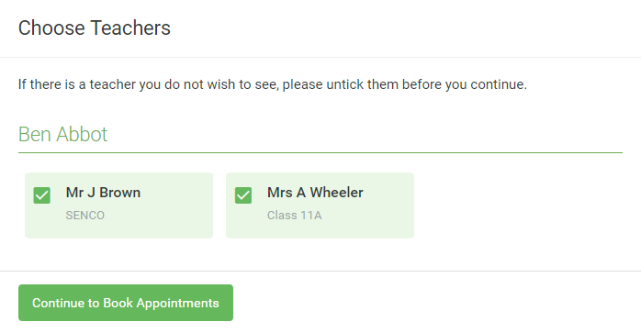 | Step 4: Choose Teachers  Select the teachers you’d like to book appointments with. A green tick indicates they’re selected. To de-select, click on their name.

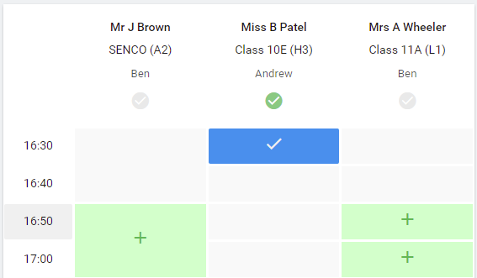 | Step 5 Book Appointments  Click any of the green cells to make an appointment. Blue cells signify where you already have an appointment. Grey cells are unavailable.  To change an appointment, delete the original by hovering over the blue box and clicking Delete. Then choose an alternate time.  Once you’re finished booking all appointments, at the top of the page in the alert box, press click here to finish the booking process.  There is an option to leave a message for the teacher. Please use this to provide any specific questions you may like answered at the meeting. Teachers will read these prior to the meetings so they can provide appropriate information.

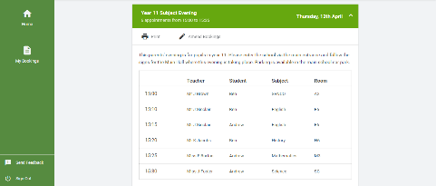 | Step 6: Finished  All your bookings now appear on the My Bookings page. An email confirmation has been sent and you can also print appointments by pressing Print. Click Subscribe to Calendar to add these and any future bookings to your calendar.  To change your appointments, click on Amend Bookings.

How long are appointments?
Appointments are 10 minutes and at the end of the 10 minutes, the system will close the meeting automatically. It is therefore very important that both teachers and parents are ready for the start of the meeting. If something comes up in the meeting that requires further discussion, the teacher will note this and contact the parent to arrange a time for another conversation.

We know that for parents of children with SEND, 10 minutes may not be adequate to discuss things in the detail that is required. Please book your 10 minutes with the class teacher and if you need more time to talk about your child’s specific needs, please email Mrs Hartmann directly who will contact you to book in time with her. This may not be on Tuesday 8th or Thursday 10th December.

What if I am late to my meeting?
There is no facility to push meetings back, once they are booked the teachers will need to keep to time. As stated above, once the 10 minute slot is complete the system shuts this session so it ready to open the next. There is a waiting room on School Cloud and this facility can be used by parents to avoid being late.

What if I miss my appointment?
Any parent who misses their appointment will need to email the class teacher directly who will contact the parent to try and arrange another time.

What information will be shared?
Teachers will share the following information:
- The child’s current attainment in Reading, Writing and Maths. This means sharing whether the child is working at age related expectations, above age related expectations or working below age related expectations.
- The child’s next step targets and if any support/provision has been or will be in place for the child to help them make progress if anything extra is needed.
- The child’s attitude to learning including who they use Learning Powers successfully in their learning.
- How parents can support their child at home.

Can my child be with me for this meeting?
We would ask that children are NOT present at these meetings. As we do not have as much face to face contact as we would like as present due to CV restrictions, teachers will need this time to focus on their discussions with parents. Children will be informed of their targets in school and so will know what they are working on and why.

Safeguarding everyone during remote meetings:
Teachers will ensure they follow the school’s set protocol for online meetings.

Please can parents ensure;

  - The location of parent during the meeting will be appropriate with nothing personal behind. We recommend a blank background if at all possible.
  - The child being discussed and their siblings or family members are being attended to, away from the meeting so that confidentiality is maintained.

Anything overheard or seen by the teacher that causes concern will lead to the immediate end of the session and parents will be contacted by a member of the SLT to discuss the incident.

When can I book my appointment?
The system is live and ready to go, so you can go on and book NOW! Please note teachers cannot swap times around so, once a time slot has been booked, it’s been booked.

When is the deadline for booking an appointment?
The deadline for booking, including registering questions is 6pm Tuesday 1st December 2020. If a parent has not booked their session by this time, the class teacher will allocate them a date and time and email this information to the parent.

Thank you for your ongoing support.

Kind regards

Mrs Pipe

