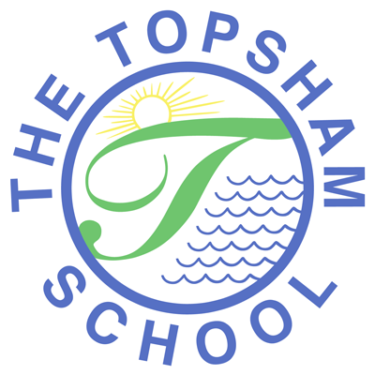
The Topsham School
A love of learning and commitment to the success of
every child at the heart of all we do

Headteacher: Mrs Emma Pipe
Orchard Way
Topsham
Exeter
EX3 0DN
admin@topsham.devon.sch.uk
01392 874498

5th January 2021

Dear Parents/Carers

I have been in consultation with my Chair of Governors and it has been decided that the school will need to remain closed to ALL children tomorrow; Wednesday 6th January 2021. This is due to the logistics, structures and procedures we are needing to put in place and having no updated government guidance to work from. Thank you for your patience and understanding.

As our Nursery is part of our school, this will also remain closed throughout this lockdown period to all children apart from those of Key Workers and those identified as vulnerable.

Please can I ask all parents to keep checking their texts and emails as a further communication is about to be sent re Key Worker in school provision.

Kind regards

Mrs Pipe

