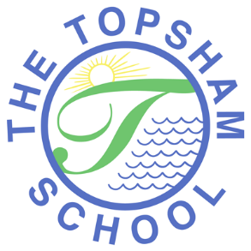
The Topsham School
A love of learning and commitment to the success of
every child at the heart of all we do

Headteacher: Mrs Emma Pipe
Orchard Way
Topsham
Exeter
EX3 0DN
admin@topsham.devon.sch.uk
01392 874498

Dear Parents and Carers,
Please use the step by step instructions below to access Google Classroom from home.
If you are using a mobile device, for example an iphone, ipad or android device, we strongly recommend you download the Google Classroom app.
If you are using a laptop, computer or chrome book, please follow the instructions as below.

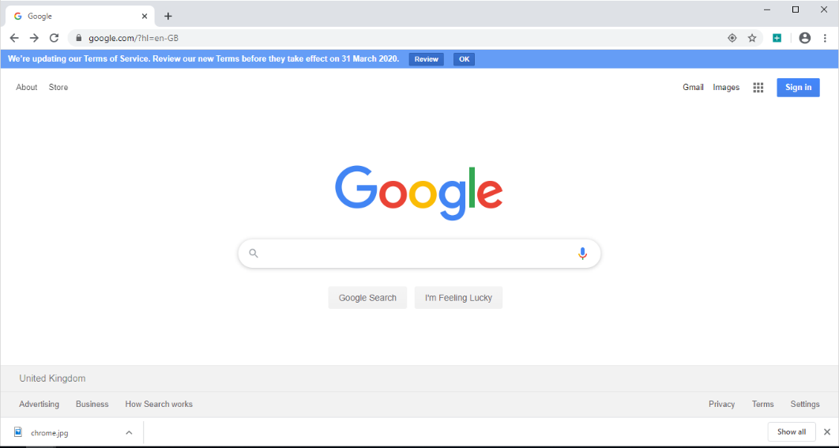
- Type into google; Google Classroom Login

You will be asked to sign in.
Your child’s login details are below.
It is made up of the following:
year of intake, first name initial, surname, @topsham.devon.sch.uk
e.g. 17sjones@topsham.devon.sch.uk
For the year of intake, please look at the list below:
Year 6- use 14 Year 3 - use 17 Year Big Acorns - use 20
Year 5 – use 15 Year 2 – use 18
Year 4 – use 16 Year 1 – use 19
The password for your child’s account is; topsham123! (all letters lowercase)
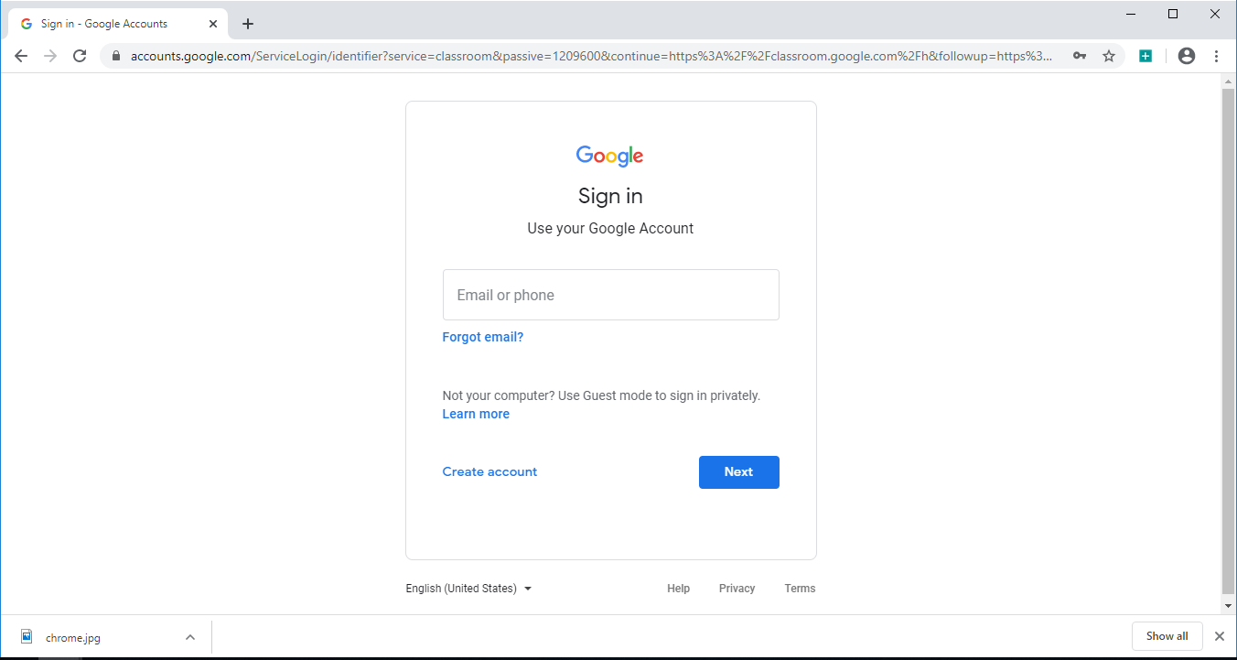

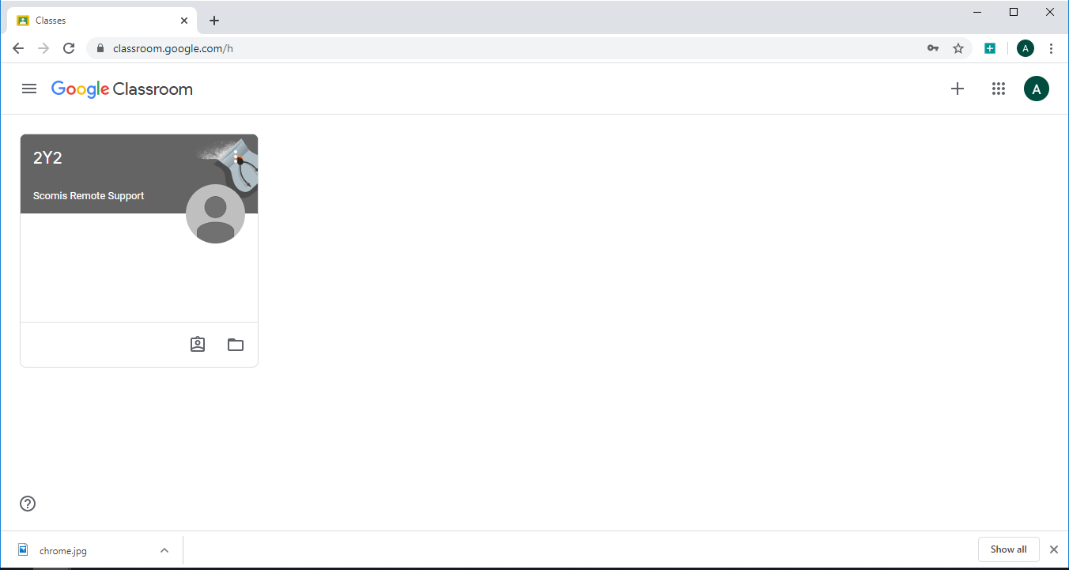
- Once logged in you will be presented with this page;
**If you are using a mobile device, follow instructions from here**

Click on the grey section at the top.
This will take you to the ‘classroom’ which looks like this (as per your year group);
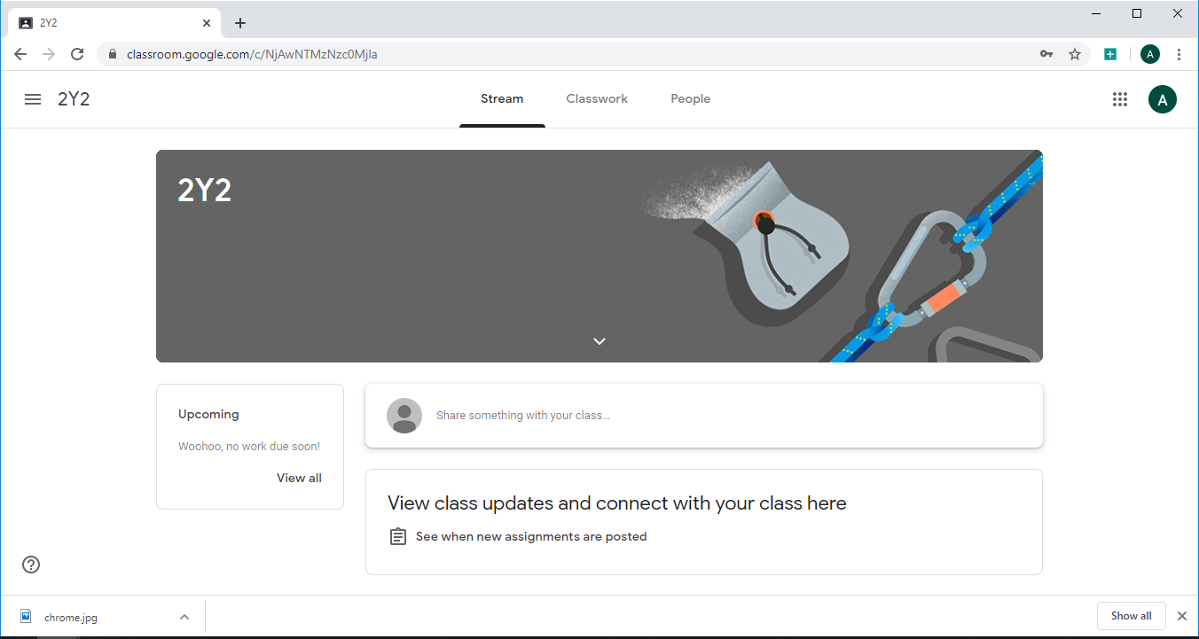
Once in the ‘classroom’ you will be able to access activities set through the tab at the top called ‘classwork’. On the left you will see what deadlines are set for each piece of work.
Depending on what work is set, children will be able to complete and ‘respond’ to the activities set.
Upon completing the task set the children will need to attach their work as directed (a photograph of written work, typed onto a new Google Docs, video, or comment) and then click ‘Turn in’ or ‘Mark as done’. It is important that this step is completed so that the teachers know when work is complete.

