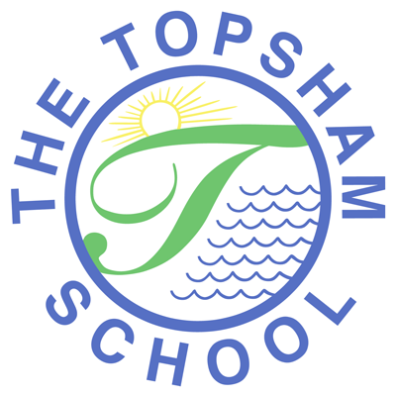
The Topsham School
A love of learning and commitment to the success of
every child at the heart of all we do

Headteacher: Mrs Emma Pipe
Orchard Way
Topsham
Exeter
EX3 0DN
admin@topsham.devon.sch.uk
01392 874498

28th January 2021
CV19 Update

School reopening
I am sure parents will have seen/heard that schools will remain closed until 8th March at the earliest. I know we will all be feeling a deep sadness about this and I know that everyone will continue to do what is needed to keep each other safe. When I receive any other information I will ensure this is shared with you.

Remote Learning
We would like to say a huge thank you to all our parents who are working so hard to support their children with their remote learning at home. We know how challenging this is for parents and we know the strains it can put on relationships; the parent/child relationship is very different to a parent/teacher relationship and you are all being asked to do both. The teaching staff have been so impressed with how well the children have engaged so far and the standard of the work they are submitting.

Please can we reassure parents again that teachers do not expect work submitted to be perfect. We expect spelling mistakes, mistakes in maths, misunderstandings etc as this is part of learning. We use these mistakes to guide our assessment and plan for next steps. If there are no mistakes, then our assessments will show the work we are setting needs to be more challenging and we need to be sure that this is a true reflection of what is needed.

Prior to lockdown we were working with the children, across the school on Building Learning Powers. This work was supporting children understand their role in the learning process and understand the skills they would need to develop and use to succeed. To support them to continue to develop these skills while at home, and to support them to be more independent. We will be sharing information about Learning Powers on our website, starting next week. Teachers will also be providing pre-recorded videos to provide parents with extra guidance in how to support children to work independently when they need to; these will be specifically linked to writing and maths. Intrinsic motivation is the key; children need to understand why they need to engage and complete learning so do keep talking to them about the long term impact of the choices they are making.

We are continuing to review and refine our Remote Learning Provision, in line with the high expectations of the DfE, and we are grateful for your feedback; to date this has been overwhelmingly positive. However, we know it is not perfect by any means which is why we will continue to make any changes deemed necessary. With this in mind we are investigating a way of ensuring we can hear from parents on a more regular basis. Information on this will be provided soon.

Attendance
During this time, schools have been asked to monitor attendance. This includes the attendance of children working remotely. This is not a school decision, it is a mandate from the DfE and is a key part of safeguarding. We understand that there can be challenges in relation to accessing registration due technology difficulties or where families with more than one child trying to get onto registration.

To help us, if you are struggling to get onto registration or cannot get on for other reasons please can you email the class teacher and copy in admin@topsham.devon.sch.uk as soon as possible. It is really important that any correspondence in relation to remote registration has admin copied in as teachers do not have the capacity to get messages to the office themselves as they are teaching, both remotely and in school.

Please bear with us if you are sent an email in relation to registration in error; everyone is trying their best.

School Office
The School Office is not closed; it is closed to visitors. We are making sure our notices are updated. Jayne and Jenny are working their normal hours in school and continuing to do an incredible job. Phone messages are picked up throughout the day as are emails. Not all emails may be responded to due to the level of correspondence at this time. Thank you

Free School Meals over Half Term
The Local Authority will be organising the provision of Free School Meals over the Half Term break as they did over the Christmas holidays. We will update parents of children in receipt of Free School Meals once we have more information.

Wellbeing
Children’s Mental Health Week is coming up on 1st February, and the theme this year is ‘express yourself’. By talking openly about mental health from a young age, children can learn to better understand their emotions, break down stigma, and feel safe enough to reach out for help when it’s needed.

Talking about mental health and expressing our feelings can be difficult, no matter our age. The link to this toolkit, has lots of great resources to help staff, children and their parents/carers start the mental health conversation.

